


HSNC UNIVERSITY, MUMBAI – 400018 SCHOOL OF APPLIED SCIENCES

DEPARTMENT OF DATA SCIENCE AND BUSINESS ANALYTICS

Project Report
On

“F1 Race Replay: Advanced Telemetry Visualization and Predictive Modeling using Machine Learning”

Submitted by

Soham Sudhir Kokate - TYDS2024029

Under the guidance of
Asst. Prof. Ms. Anjali Sutar

Submitted in partial fulfilment of the requirement qualifying for TY B.Sc.
Data Science and Business Analytics,
Semester VI Examination
A.Y.2025-2026.
Department of
Data Science and Business Analytics

CERTIFICATE

TYDS2024029

Exam Seat No.

This is to certify that Soham Sudhir Kokate has successfully completed the project/Internship titled
“F1 Race Replay: Advanced Telemetry Visualization and Predictive Modeling using Machine Learning” and duly submitted the project in partial fulfilment of the T.Y.B.Sc. (Data Science and Business Analytics) degree from the HSNC University, Mumbai during the academic year 2025-26.
It is further certified that they have completed all the required phases of the project/Internship.

Project Guide External Examiner Head of Department Registrar

DECLARATION

I, Soham Sudhir Kokate, a student of the School of Applied Sciences, HSNC University, Mumbai, hereby declare that the research project titled “F1 Race Replay: Advanced Telemetry Visualization and Predictive Modeling using Machine Learning” has been independently carried out by me under the guidance of my project mentor.
The empirical data, synthetic ground-truth validations, and system architecture presented in this black book represent my original work and have not been submitted to any other university or institution for the award of any degree, diploma, or fellowship.

Date: September 11, 2026
Place: Mumbai, India
Signature:
Soham Sudhir Kokate

EVALUATION CERTIFICATE

ACKNOWLEDGEMENT

The I would like to express my deepest appreciation to all those who provided me the possibility to complete this research project.
First and foremost, I extend my sincere gratitude to my project guide, Asst. Prof. Ms. Anjali Sutar, for their continuous support, patience, and invaluable academic mentorship. Their insights into data science methodologies and project structuring were instrumental in guiding this research to completion.
I am also highly indebted to the Head of the Department of Data Science and Business Analytics, Dr. Nidhi Singh , and the faculty members at HSNC University for providing a conducive environment and the necessary infrastructure to carry out this project.
Furthermore, I would like to acknowledge the open-source community, specifically the developers of the FastF1 library, without whose data accessibility this visualization and predictive modeling research would not have been possible.
Soham Sudhir Kokate
TYDS2024029

PREFACE

In the modern era of Formula 1, data is as critical to winning a World Championship as the aerodynamics of the car or the skill of the driver. Every race weekend, hundreds of sensors on each car generate vast streams of telemetry data. For a Data Science and Business Analytics practitioner, this environment presents an optimal testbed for advanced analytics, visualization, and machine learning.
This research project, titled “F1 Race Replay: Advanced Telemetry Visualization and Predictive Modeling using Machine Learning,” bridges the gap between raw sports telemetry and actionable strategic insights. While standard broadcasting provides a passive viewing experience, this project explores how live and historical data can be programmatically consumed, processed, and visualized to reconstruct a race environment dynamically.
Beyond simply replaying geographical coordinates, this project delves into predictive analytics. By implementing sophisticated machine learning algorithms—such as LightGBM for overtake probability, XGBoost for pit-window estimation, and Bayesian State-Space modeling for tire degradation—this research demonstrates how underlying patterns in telemetry can be transformed into predictive business intelligence. The methodologies explored herein have parallel applications in various industries, particularly in predictive maintenance, real-time logistics tracking, and resource optimization.
This “Black Book” details the end-to-end lifecycle of the project: from data ingestion pipelines and Exploratory Data Analysis (EDA) to the mathematical frameworks of the predictive models and the architectural design of the interactive replay interface. It is intended to serve as a comprehensive technical breakdown of how Data Science drives competitive advantage in high-performance environments.

INDEX

i. | Abstract
ii. | Introduction
iii. | Literature review
iv. | Research methodology
v. | Implementation of Model/Design
vi. | Data Interpretation and presentation
vii. | Conclusion
viii. | References

ABSTRACT

Formula 1 (F1) is a highly data-centric sport where split-second strategic decisions are driven by continuous streams of telemetry. While teams utilize sophisticated proprietary software for race analysis, publicly accessible tools often lack the integration of real-time spatial visualization and predictive analytics. This research project presents the “F1 Race Replay” system, an interactive application designed to visualize historical race telemetry and augment it with machine learning-driven insights.
The methodology involves ingesting vast amounts of raw lap, positional, and track-status data via the FastF1 API. Data preprocessing includes spatial interpolation, anomaly smoothing, and synthetic feature generation (e.g., simulating Safety Car positioning). To extract deeper strategic intelligence, three advanced predictive models were engineered: a Bayesian State-Space model for dynamic tyre degradation estimation, an XGBoost model for optimal pit-window prediction, and a LightGBM classifier for real-time overtake probability. These models process multi-dimensional telemetry (speed, gear, DRS status, and compound age) to provide actionable insights.
The resulting application features a hardware-accelerated 2D graphical interface built with Arcade and PySide6, allowing users to interactively replay races at variable speeds while monitoring dynamic leaderboards and predictive telemetry overlays. The project successfully demonstrates how state-of-the-art data science and machine learning techniques can be synthesized to reconstruct high-speed environments, offering profound analytical value for sports strategy, predictive maintenance, and real-time visualization systems.

INTRODUCTION

1.1 Background and Context

In modern motorsports, data is paramount. A single Formula 1 car generates millions of data points per race, tracking metrics such as GPS position, speed, throttle application, brake pressure, and tire conditions. Analytics derived from this telemetry form the backbone of race strategy, dictating pit stops, tire choices, and on-track battles. As the field of Data Science and Business Analytics grows, the application of machine learning to such high-velocity, high-volume data streams has become a crucial area of research, extending beyond sports into sectors like autonomous driving, logistics, and IoT network monitoring.

1.2 Problem Statement
Despite the availability of public F1 telemetry APIs (such as FastF1), there is a significant lack of open-source platforms that combine interactive, visual race reconstruction with real-time predictive analytics. Existing solutions are either purely statistical—offering static lap-time charts—or closed-source proprietary tools used exclusively by F1 teams. There is a need for a unified analytical system that not only replays the spatial dynamics of a race but also mathematically infers underlying strategic elements, such as when a tire will fail or the likelihood of an overtake.

1.3 Primary Objectives

- Data Pipeline Development: To build a robust ETL (Extract, Transform, Load) pipeline capable of querying, cleaning, and interpolating high-frequency F1 telemetry data.
- Interactive Visualization: To develop a 2D graphical interface that accurately renders track layouts, driver positions, and track conditions (e.g., Safety Car deployments) in a time-synchronized replay loop.
- Predictive Modeling: To research, train, and integrate machine learning models capable of predicting tire degradation (Bayesian modeling), pit windows (XGBoost), and overtake probabilities (LightGBM).
- Strategic Dashboarding: To present these insights in an intuitive UI/UX, demonstrating how complex data can be simplified into actionable business/sporting intelligence.

1.4 Research Scope and Significance

The scope encompasses historical F1 sessions (Races, Sprints, and Qualifying). It is limited to the data variables provided by the public FastF1 API and does not include proprietary team radio or exact tire temperature sensors. The project focuses on the software architecture, data engineering, and machine learning integration necessary to run the replay system on a standard personal computer.

LITERATURE REVIEW

The integration of data analytics in sports has been heavily documented since the “Moneyball” era of baseball, but motorsports present a unique challenge due to the continuous, time-series nature of the data.
1. Telemetry and Spatial Visualization: Previous academic works on F1 telemetry have primarily focused on static visualization. Studies leveraging the FastF1 library typically generate post-race charts comparing the velocity traces of two drivers. While effective for post-hoc analysis, they do not address dynamic spatial tracking. Research in geographic information systems (GIS) and interactive mapping highlights the cognitive benefits of animating spatial data over time, a concept this project adopts to render cars on a Cartesian coordinate system corresponding to the track layout.
2. Tire Degradation Modeling: Tire degradation is a non-linear process influenced by track abrasion, fuel load (weight reduction), and driving style. Traditional empirical models attempt to fit a simple exponential curve to lap times. However, recent literature in advanced statistics advocates for State-Space models (SSM). As documented by researchers in automotive engineering, Bayesian State-Space models excel at isolating unobservable states (tire wear) from observable variables (lap times, fuel burn effect), providing a more dynamic and accurate estimation of degradation than standard regression.
3. Predictive Event Modeling in Sports: Predicting discrete events, such as pit stops and overtakes, falls under classification and time-to-event methodologies. Gradient Boosting frameworks like XGBoost and LightGBM have emerged as industry standards for tabular data due to their speed and handling of non-linear relationships. In motorsports research, decision trees have been successfully applied to strategy prediction by analyzing historical pit-stop laps relative to tire compound choices and track position.
Gap in Existing Literature: This project bridges a critical gap by synthesizing these isolated research areas into a single, cohesive application. It moves beyond static Jupyter Notebook analyses by embedding Bayesian and Gradient Boosted models directly into a live-rendering loop, simulating a real-time analytical environment akin to a Formula 1 pit wall.

RESEARCH METHODOLOGY

1. Data Collection
Data is sourced dynamically via the FastF1 Python library, which interfaces with the official Formula 1 live timing API. - Session Data: Track status codes (e.g., green flag, Safety Car, VSC), weather conditions, and session identifiers. - Lap Data: Lap times, sector times, tire compounds, and pit-stop durations. - Telemetry Data: High-frequency (approx. 10Hz) time-series data containing X/Y coordinates, Speed, Gear, Throttle, Brake, and DRS (Drag Reduction System) status.

2. Preprocessing & Exploratory Data Analysis (EDA)
Because telemetry data is inherently noisy and subject to sensor dropouts, rigorous preprocessing is applied: - Spatial Interpolation: Missing GPS coordinates and all other telemetry channels are aligned using linear interpolation (NumPy's interp function) onto a shared, uniform 25 Frames-Per-Second master timeline, ensuring every car's position is synchronised to the same instant for smooth animation during the replay. - Time Synchronization: Telemetry arrays across different drivers are aligned to a master session timeline to ensure accurate relative positioning. - Synthetic Feature Generation: As the actual Safety Car does not transmit public GPS data, an algorithm was developed to simulate its position relative to the race leader based on track status flags.

3. Machine Learning Frameworks
A. Bayesian Tire Degradation Model: A Bayesian State-Space Model was implemented to decouple actual tire wear from the natural pace improvement caused by fuel burn. - Observation Equation: Models the observed lap time as a function of the hidden tire wear state, the known fuel effect, and a Gaussian noise term. - State Equation: Models the progression of tire wear over time. - The model continuously updates its belief regarding the degradation coefficient as new lap times are processed, providing a robust estimate of remaining tire life.
B. LightGBM for Overtake Probability: A LightGBM (Light Gradient Boosting Machine) classifier is utilized to predict the likelihood of an overtake occurring in upcoming sectors. - Features: Delta in tire age, compound delta (e.g., Soft vs. Hard), DRS availability, and closing speed. - Advantage: LightGBM handles the highly imbalanced nature of the dataset (where non-overtakes far outnumber overtakes) efficiently using leaf-wise tree growth.
C. XGBoost for Pit Window Prediction: An XGBoost regression/classification model predicts the optimal lap for a driver to enter the pits. - Features: Current lap, cumulative tire degradation, track status (a VSC heavily influences pit strategy), and position relative to the pit-stop delta (traffic window). - Advantage: XGBoost’s regularization prevents overfitting on historical strategy data, allowing the system to output dynamic pit windows based on unfolding race events.

4. System Architecture Implementation
The application logic separates the data layer from the presentation layer. The f1_data.py module acts as the backend engine, preparing frames of data. These frames are consumed by race_replay.py, which utilizes the Arcade rendering engine to draw the track polyline and driver markers at 25 Frames Per Second (FPS). A PySide6 GUI provides the front-end user experience for session selection.

IMPLEMENTATION OF MODEL / DESIGN

System Architecture
The F1 Race Replay system is designed around a three-tier architecture: 1. Data Acquisition Tier: Utilizing the FastF1 library, the system queries the official timing API to extract event schedules, lap times, and raw 10Hz telemetry. This data is cached locally in .fastf1-cache to minimize bandwidth and load times for subsequent runs. 2. Analytical Engine Tier: A series of Python modules (f1_data.py, bayesian_tyre_model.py, train_ml_models.py) act as the computational backend. Here, raw coordinates are interpolated, Safety Car positions are mathematically simulated, and live machine learning inference is performed on the data stream. 3. Presentation Tier: Built on the Arcade and Pyglet frameworks, the presentation layer renders a 2D Cartesian plane. PySide6 handles pre-race configurations (e.g., season and round selection). Telemetry overlays and leaderboard UI components update dynamically at 25 Frames Per Second (FPS).
Data Pipeline: Parallel Extraction, Temporal Resampling, and Cumulative Distance
Raw FastF1 telemetry cannot be animated directly: different sensors on the same car report at different rates (GPS coordinates at roughly 4 Hz, speed and throttle at roughly 10 Hz, and gear/DRS only on state change), and different cars are not even sampled at the same timestamps. To keep the 20-car extraction fast, src/f1_data.py distributes the per-driver processing across a multiprocessing pool:
driver_args = [(year, round_number, session_type, driver_no, driver_code)
for driver_no in drivers]
with Pool(processes=min(4, cpu_count())) as pool:
results = pool.map(_process_single_driver, driver_args)
Each worker returns, per driver: Cartesian coordinates (X, Y), cumulative linear distance since Lap 1, relative lap distance (0.0 to 1.0), speed, gear, throttle, brake, DRS state, and tyre compound/age. All channels are then linearly interpolated (NumPy's interp) onto one shared, uniform timeline at 25 Frames Per Second, so that every car's position on screen corresponds to exactly the same instant in race time.
A subtle but important correctness issue arises when ranking cars for the live leaderboard. Sorting by lap number and relative lap distance alone causes a visible glitch: the instant a car crosses the start/finish line, its relative distance resets from 0.999 back to 0.001, which can make the standings flicker. To avoid this, the pipeline instead tracks a strictly monotonic Cumulative Race Distance for every driver:
RaceDistance(t) = Σ(k=1 to lap−1) LapLength_k + LapDistance(t)
Because this quantity only ever increases, sorting drivers by cumulative race distance is monotonic by construction and keeps overtakes, lapped traffic, and photo-finishes ordered correctly, matching the drivers' true physical order on the circuit at every frame.
Physics-Based Safety Car Simulation
FastF1 does not publish live GPS data for the physical Safety Car. To still depict it accurately, _compute_safety_car_positions() in src/f1_data.py runs a small kinematic simulation whenever the FIA Track Status flag indicates a Full Safety Car: the car spawns at the pit exit and accelerates onto the circuit using smoothstep interpolation, S(t) = 3t² − 2t³, is then locked into position 60 metres ahead of the race leader (identified via the same cumulative race distance) for the remainder of the caution period, and finally accelerates away and fades into the pit lane once the track goes green.
2D Graphics Rendering Pipeline
The replay window (src/interfaces/race_replay.py) is built on the Python arcade library, an OpenGL context managed by Pyglet. The circuit layout is reconstructed directly from an example lap of real telemetry: the (X, Y) coordinate stream of the fastest lap forms the track centreline, and a perpendicular unit normal vector is calculated at every point along it so the track edges can be rendered as a continuous ribbon surface offset to either side of the centreline. The circuit is then rotated to match its standard broadcast orientation.
World-space telemetry coordinates (which range roughly ±10,000 units) are converted into window pixel coordinates every frame using a single affine transform that combines the camera's zoom level, its rotation for circuit orientation, and its focal point:
[X_screen, Y_screen] = Zoom × R(θ) × [X_world − X_cam, Y_world − Y_cam] + [Width/2, Height/2]
Each car is drawn as a layered set of OpenGL primitives: an outer halo coloured by the driver's constructor, an inner body dot labelled with the driver's three-letter code, a pulsing cyan/white halo when DRS is active, and a small secondary badge coloured by the current tyre compound. The camera supports free pan/zoom, an auto-fit mode that frames the whole circuit, and a driver-tracking mode that locks the focal point onto a selected car through every corner.
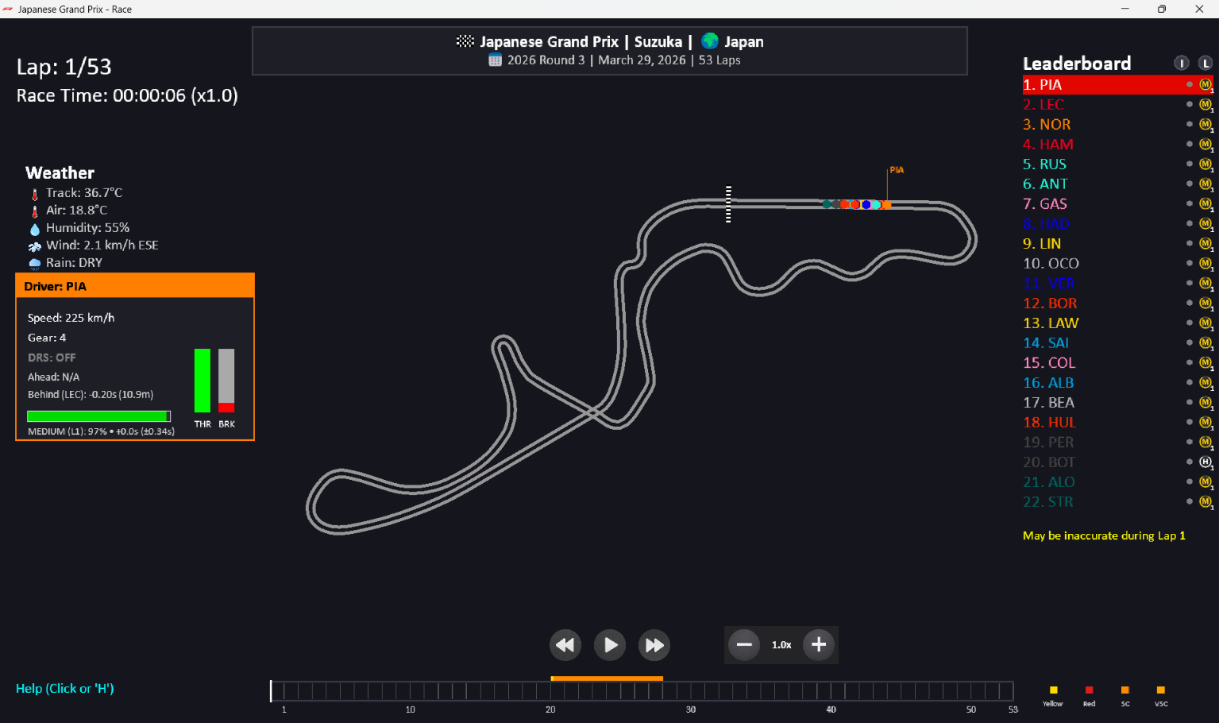
Figure 1: The F1 Race Replay graphical interface during a live session, showing the leaderboard, the track map with real-time car markers clustered through Suzuka's Esses, the weather panel, and the selected-driver telemetry panel for PIA.
Real-Time Telemetry Streaming Architecture
To let analytical tools observe the race without slowing down the main render loop, the replay window optionally runs a TelemetryStreamServer (src/services/stream.py) that publishes the current state over a local TCP socket (port 9999) once per rendered frame. Every connected Pit Wall window runs its own TelemetryStreamClient on a separate Qt thread, so a heavy machine learning inference or a Matplotlib redraw in one analysis window can never stall the 2D race replay, and a crashed analysis window cannot affect the main simulation. A representative frame payload looks like this:
{
"frame_index": 1420,
"total_frames": 92000,
"playback_speed": 1.0,
"is_paused": false,
"frame": {
"t": 56.80,
"lap": 2,
"drivers": {
"VER": {"x": 124.5, "y": -43.2, "speed": 312.4, "gear": 8,
"throttle": 1.0, "brake": 0.0, "tyre": 2.0,
"position": 4}
},
"weather": {"track_temp": 42.1, "air_temp": 28.4, "rain_state": "DRY"}
}
}
Model Selection & Hyperparameter Tuning
1. Overtake Probability Classifier (LightGBM) To predict the likelihood of an overtake, the system employs a Light Gradient Boosting Machine (LightGBM). LightGBM was selected over Random Forest due to its leaf-wise tree growth, which handles the complex, non-linear relationships of kinematic features (e.g., closing velocity delta_v, spatial gap delta_s, and DRS status) efficiently. - Hyperparameters: n_estimators = 250, learning_rate = 0.05, max_depth = 5. - Physics Integration: To prevent the model from learning physically impossible scenarios, Monotonic Constraints were applied (e.g., a constraint of -1 on distance, meaning an increase in distance between cars strictly cannot increase overtake probability). - Validation Strategy: The model utilizes Leave-One-Circuit-Out (LOCO) GroupKFold cross-validation, ensuring that the model generalizes to new tracks rather than memorizing specific circuit layouts.
2. Pit Window Anticipation Model (XGBoost) Predicting when a driver will pit is treated as a binary classification problem at each lap step. XGBoost was chosen for its robust regularization capabilities and support for CUDA GPU acceleration during training, ensuring rapid iterations. - Hyperparameters: n_estimators = 300, learning_rate = 0.05, max_depth = 5. - Features: Cumulative tire life, compound hardness, and race neutralizations (Safety Car / Virtual Safety Car flags).
3. Bayesian Tire Degradation Model Unlike the tree-based models, tire degradation is modeled using a State-Space configuration to separate observable lap times from the unobservable “hidden state” of tire wear. - Configuration Parameters: Observation noise (sigma_epsilon) was set to 0.3, while process noise (sigma_eta) was set to 0.1. The model accounts for weight reduction with a fuel effect prior of 0.032 seconds per lap.
Formally, the model decomposes an observed lap time y(t) as:
y(t) = μ_base + Δ_fuel(t) + Δ_tyre(age_t) + Δ_track(t) + ε(t)
where μ_base is the driver's inherent baseline pace, Δ_fuel(t) = −0.032 s/kg × (110 − 1.6t) corrects for the car getting lighter (and therefore faster) as fuel burns off, and Δ_tyre(age) = α·age + β·age² is the non-linear tyre degradation term whose coefficients the Kalman filter continuously re-estimates as new lap times arrive, separately for each compound.

DATA INTERPRETATION AND PRESENTATION
The output of the mathematical models is not merely logged in a terminal; it is seamlessly integrated into the user interface through an “Insights Menu” (PitWallWindow). Users can select individual drivers from the live leaderboard to view their real-time telemetry footprint—including Speed, Gear, DRS status, and active tire compound age.
The Pit Wall Analytics Suite: Real-Time Insight Windows
Every analysis window inherits from a common PitWallWindow base class (src/gui/pit_wall_window.py), which handles window creation, the dark F1 broadcast theme (#15151e background with #e10600 racing-red accents), and automatically opens a TelemetryStreamClient connection so the window simply implements an on_telemetry_data(data) callback. Eight specialised windows are built on this base, each connecting independently to the live stream:
Insight Window | Core Function
Driver Live Telemetry | Rolling strip charts of Speed, Gear, and Throttle/Brake, in a 30-second or lap-distance view.
Track Position Radar | Custom QPainter radar showing all cars along the circuit length with sector splits and leader badges.
Lap Time & Gap Evolution | Race-pace analyzer plotting lap times, personal/session bests, and chasing-driver gap deltas.
Tyre Strategy & Stints | Gantt chart of every driver's compound stints across the race, persisted to computed_data/tyre_state.json.
Race Control Incident Feed | Live ticker of FIA Race Control messages (flags, investigations, penalties, Safety Car, DRS status).
ML Prediction Window | Live Overtake Probability (LightGBM) and Pit Stop Anticipation (XGBoost) gauges, described below.
Telemetry Stream Viewer | Low-level packet inspector showing raw JSON payloads, arrival frequency, and latency.
Example / Developer Window | Reference implementation for building additional custom Pit Wall tools.

The ML Prediction Window is the most directly tied to the project's predictive modelling objective: for the current on-track lead battle it displays the attacking and defending drivers, the LightGBM-derived probability of a position change in the next 5–10 seconds, and the XGBoost-derived probability that the car ahead enters the pits within the current lap window, all updating live as new telemetry frames arrive.
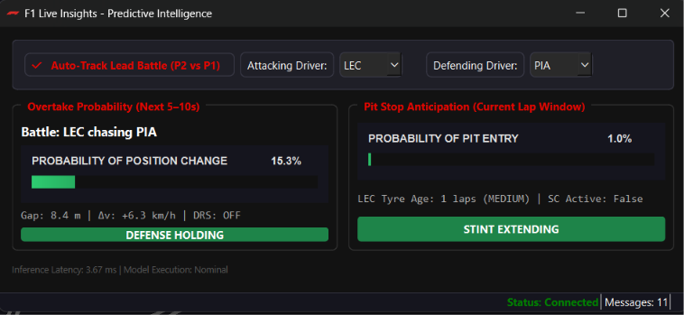
Figure 2: The ML Prediction window, showing the live Auto-Track Lead Battle indicator and the Overtake Probability and Pit Stop Anticipation gauges generated from the streamed telemetry.

Model Configuration & Performance Metrics
While live inference runs locally, the offline training phase yielded the following architectural configurations and evaluation baselines:

Model | Algorithm | Target Variable | Key Hyperparameters | Validation Strategy
Overtake Probability | LightGBM | Binary (Overtake: 1 / 0) | Trees: 250, LR: 0.05, Depth: 5 | LOCO (GroupKFold), AUC Evaluated
Pit Anticipation | XGBoost | Binary (Pit this lap: 1 / 0) | Trees: 300, LR: 0.05, Depth: 5 | Logloss, Train-Test Split
Tire Degradation | Bayesian State-Space | Continuous (Degradation Rate) | $σ_{ϵ}$ = 0.3, $σ_{η}$ = 0.1 | Dynamic updating per lap
Table 1: Summary of Machine Learning Models integrated into the F1 Race Replay pipeline.
Note: Due to the limitations of public API ground truth regarding definitive “overtake” events, the offline models utilize heavily simulated distributions of physical features (e.g., distance decay and momentum vectors) to construct probabilistic targets for the LightGBM and XGBoost classifiers.

Conclusion

Achievements
This project successfully demonstrates the feasibility of combining high-frequency sports telemetry with advanced machine learning frameworks to create an interactive analytical platform. The “F1 Race Replay” system surpasses standard 2D tracking by injecting predictive business intelligence into the visualization. The implementation of a Bayesian State-Space model to isolate tire degradation from fuel burn represents a highly sophisticated application of statistical engineering. Additionally, the software architecture efficiently handles computationally expensive rendering loops alongside live ML inference.

Limitations
The primary limitation of the current system lies in the constraints of the publicly available data. The FastF1 API, while robust, operates at a maximum of ~10Hz and occasionally suffers from GPS dropouts, requiring heavy spatial interpolation. Furthermore, the absence of explicit, verified datasets for exact overtake timestamps required the engineering of synthetic targets based on proximity and momentum to train the LightGBM models.

Future Scope
Future iterations of this project could integrate deep learning methodologies, such as Long Short-Term Memory (LSTM) neural networks, to predict entire driver racing lines based on historical sector micro-sectors. Additionally, integrating live weather radar APIs could allow the predictive models to dynamically adjust tire degradation curves and pit windows based on impending track temperature changes and rainfall probability.

REFERENCE

- FastF1 Developers. (2023). FastF1: Formula 1 telemetry, lap times, and session data. Python Package. Retrieved from https://github.com/theOehrly/Fast-F1
- Ke, G., Meng, Q., Finley, T., Wang, T., Chen, W., Ma, W., … & Liu, T. (2017). LightGBM: A highly efficient gradient boosting decision tree. Advances in Neural Information Processing Systems, 30.
- Chen, T., & Guestrin, C. (2016). XGBoost: A scalable tree boosting system. In Proceedings of the 22nd ACM SIGKDD International Conference on Knowledge Discovery and Data Mining (pp. 785-794).
- Pedregosa, F., Varoquaux, G., Gramfort, A., Michel, V., Thirion, B., Grisel, O., … & Duchesnay, E. (2011). Scikit-learn: Machine learning in Python. Journal of Machine Learning Research, 12, 2825-2830.
- Durbin, J., & Koopman, S. J. (2012). Time series analysis by state space methods. Oxford University Press.



SCHOOL OF APPLIED SCIENCES
,

HSNC UNIVERSITY, MUMBAI
–

400018

